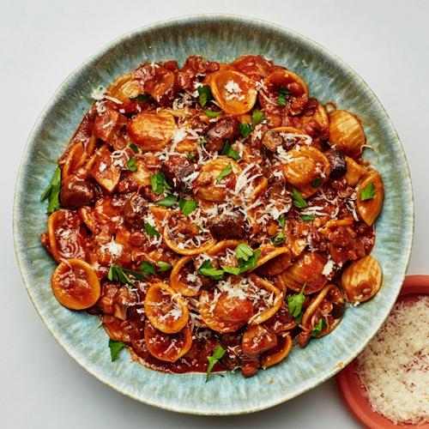Pasta with Lentils and Mushrooms

|  |
| --- |
| Ingredients With Measurements  * ¼ cup olive oil * 1 medium onion, finely chopped * 8 oz. cremini mushrooms, stems trimmed, chopped into ¼" pieces * 1 teaspoon. kosher salt, plus more * 2 garlic cloves, coarsely chopped * 1 cup brown lentils, rinsed * ¼ cup double-concentrated tomato paste * ½ teaspoon. crushed red pepper flakes * 10 oz. orecchiette pasta * 1½ oz. Parmesan, finely grated (about ½ cup) * 3 Tablespoon. unsalted butter, cut into pieces * ½ cup coarsely chopped parsley |

|  |
| --- |
| Recipe Heat oil in a large Dutch oven or other heavy pot over medium. Add onion and mushrooms and cook, stirring occasionally, until mushrooms are deeply browned and really starting to stick to bottom of pot, 12–14 minutes. Season lightly with salt.  Add garlic, lentils, tomato paste, and red pepper flakes and cook, stirring often, until tomato paste darkens slightly and lentils are coated, about 2 minutes. Add 6 cups water and bring to a boil. Reduce heat and simmer gently until lentils are tender but still have some bite, 10–12 minutes.  Add pasta and 1 teaspoon. salt to pot. Increase heat and bring to a boil. Reduce heat and simmer, stirring often (especially as the liquid starts to reduce toward the end) and adding very hot water by ½ cupful’s as needed if liquid is reducing too fast, until pasta is cooked through and liquid is reduced, 10–14 minutes.  Remove pot from heat and stir in Parmesan, butter, and ½ cup parsley. Taste and season with more salt if needed.  Divide among bowls and top with more Parmesan and parsley. |

|  |  |  |  |  |  |  |  |  |  |
| --- | --- | --- | --- | --- | --- | --- | --- | --- | --- |
| |  |  |  | | --- | --- | --- | | Olive Oil | Onion | Cremini Mushrooms | | Salt | Garlic | Brown Lentils | | Double-Concentrated Tomato Paste | Red Pepper Flakes | Orecchiette Pasta |  Ingredients Without Measurements |